Mobile Number +91-97066-09966
Email: pashupatitechnodreams@gmail.com

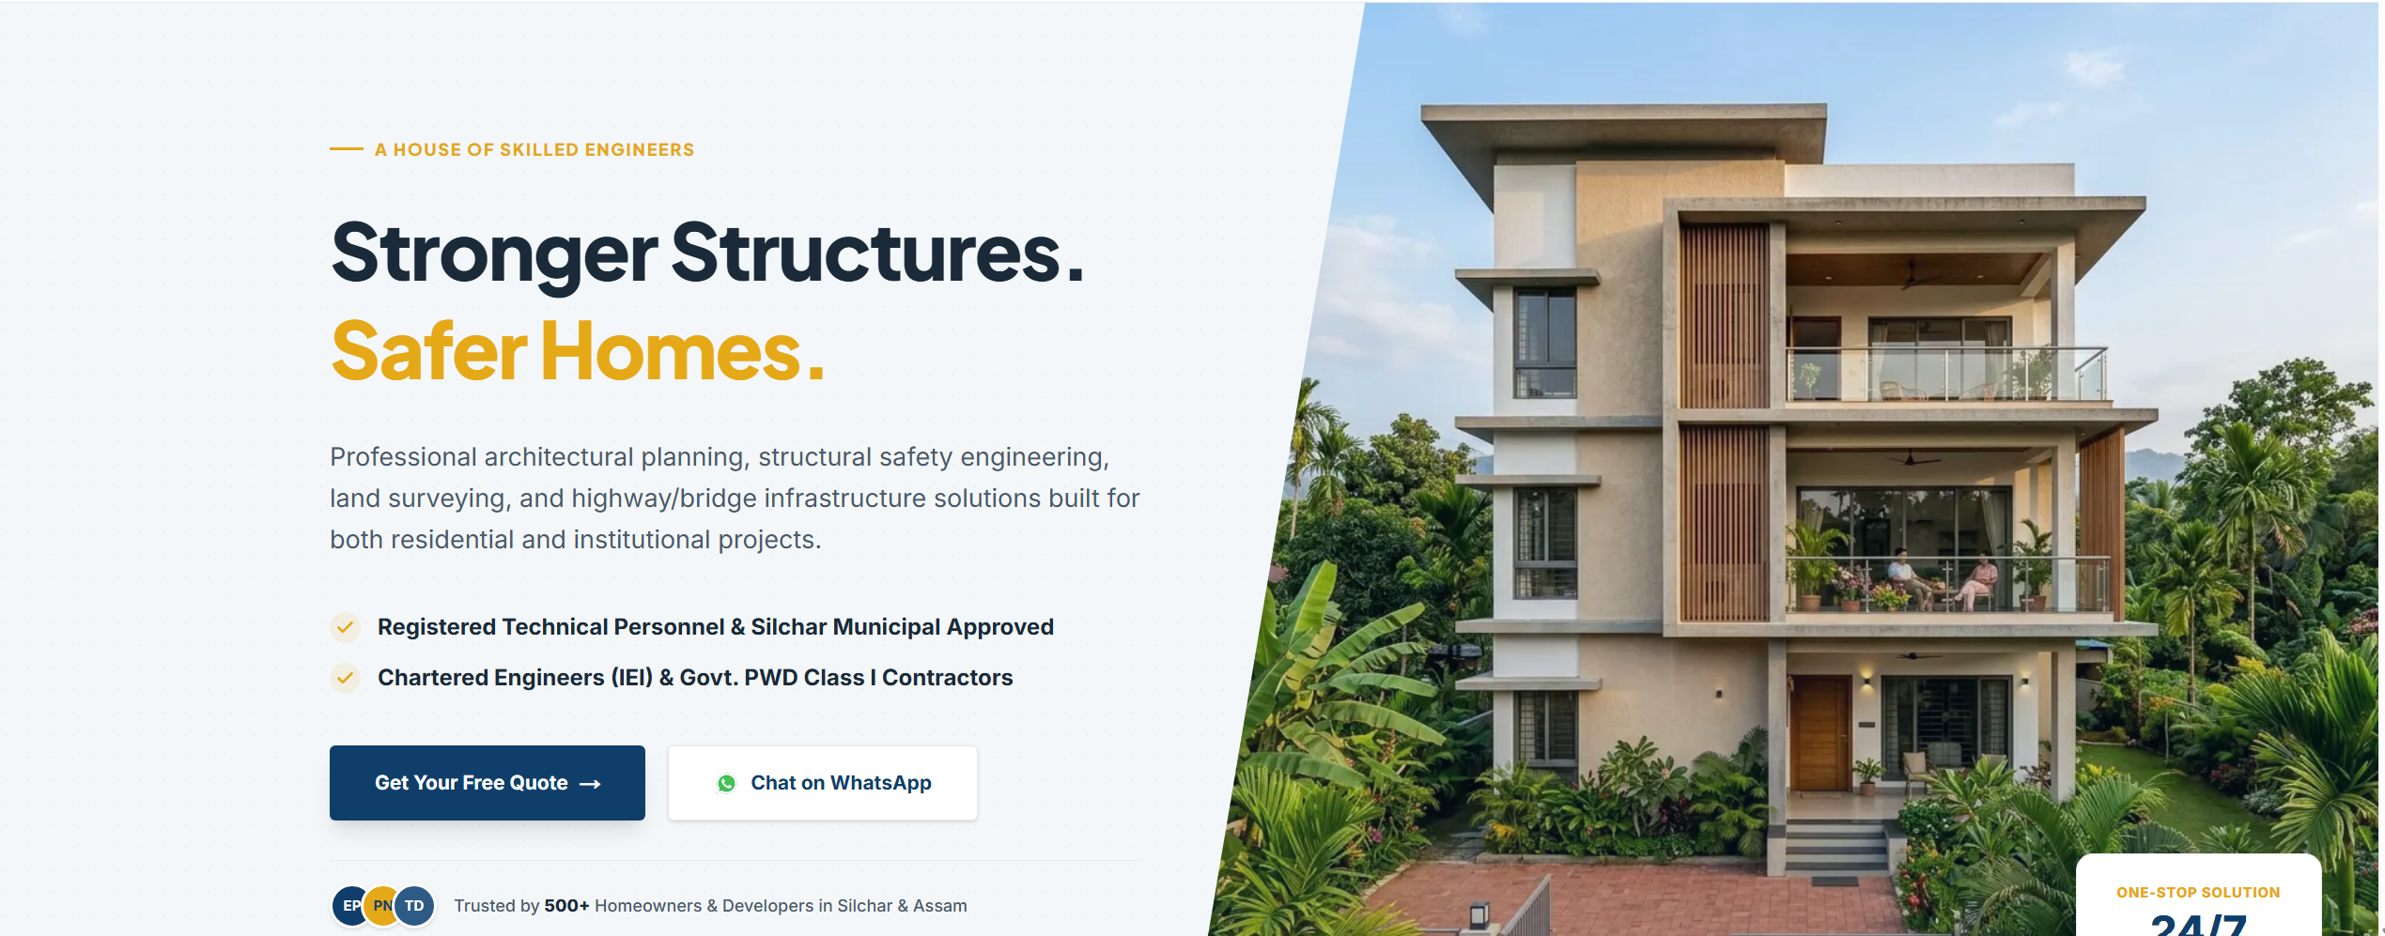
Your trusted partner in engineering and construction consultancy, offering integrated civil and structural engineering, architectural and Vastu-compliant planning, precision land surveying, and highway and bridge infrastructure design. We combine technical excellence, innovation, and regulatory compliance to deliver resilient, sustainable, and value-driven solutions across the built environment.
- A House of Chartered Engineers
- Empanelled with the Government of Assam
- Empanelled with Government of India Organizations

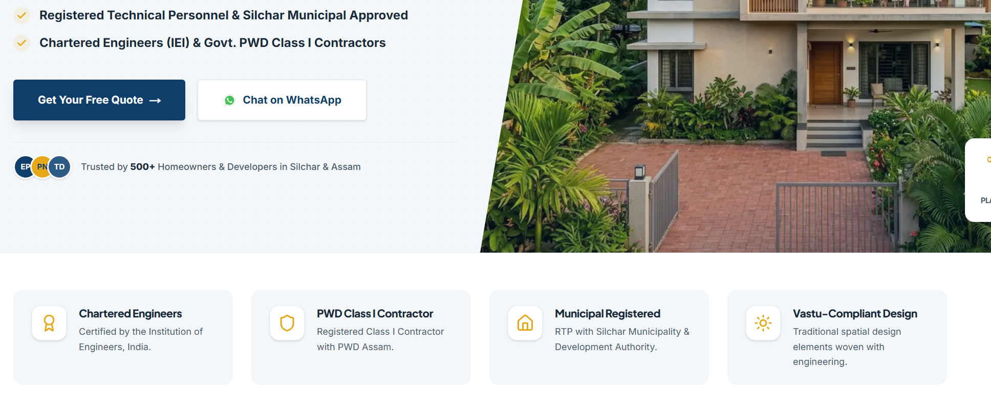
- Chartered Engineers
Certified by The Institution of Engineers(India) under the Royal Charter UK
- Vastu-Compliant Design
The old traditional of rule of wellbeing of a family, the rule of energy.
- Municipal Approval
Get approval drawing of all Municipal Board/Corporation and Development Authorities Across Assam
- Estimate for Construction
Get your estimate of construction before you start for a better planning.

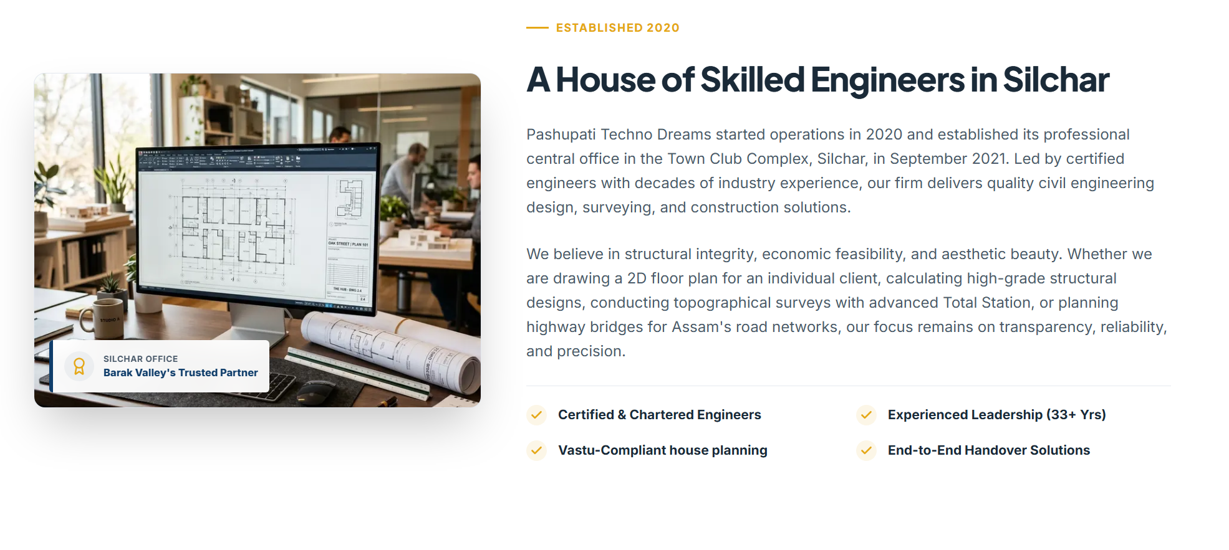
A House of Skilled Engineers in Silchar
Established in 2020, Pashupati Techno Dreams has grown into a trusted multidisciplinary construction consultancy, operating from its corporate office at Town Club Complex, Silchar, since September 2021. Guided by a leadership team with over 30 years of combined professional experience in civil engineering, construction consultancy, infrastructure development, and project management, we are committed to delivering engineering solutions that meet the highest standards of quality, safety, and innovation.
Our expertise spans civil and structural engineering, architectural and Vastu-compliant planning, precision land surveying, project management, and infrastructure design. From residential and commercial developments to institutional buildings, highways, and bridge engineering, every project is executed with meticulous technical precision and unwavering professional integrity.
At Pashupati Techno Dreams, we believe that successful engineering is built on three core principles—structural excellence, economic efficiency, and architectural elegance. Whether preparing detailed architectural plans, designing resilient structures, conducting high-precision topographical and cadastral surveys using advanced Total Station and drone technology, or delivering infrastructure solutions for public and private sector projects, our commitment remains the same: transparency, reliability, innovation, and engineering excellence.

Our Professional Engineering Services
We provide comprehensive engineering and construction consultancy services, delivering integrated solutions from concept to completion. Our multidisciplinary expertise encompasses architectural and Vastu-compliant planning, civil and structural engineering, precision land surveying, geospatial mapping, project management, transportation infrastructure design, and construction advisory. Every assignment is executed with technical excellence, regulatory compliance, innovation, and a commitment to delivering safe, sustainable, and cost-effective solutions.

- Architectural Planning & Design – Concept development, detailed architectural drawings, and functional space planning.
- Structural Engineering & Design – Structural analysis, RCC and steel design, structural drawings, and safety certification.
- Construction Planning & Project Management – Project scheduling, cost control, quality assurance, contract administration, and site supervision.
- Vastu-Compliant Architectural Planning – Scientifically planned layouts integrating modern design principles with Vastu guidelines.
- 3D Architectural Visualization – High-quality 3D floor plans, exterior elevations, interior concepts, and realistic project renderings.
- Instant Residential Building Approval – Preparation and submission of drawings under MMSGNA for Residential upto G+2 building with instant approval
- Building Permit & Statutory Approval Drawings – Approval drawings and documentation in compliance with municipal and development authority regulations.
- Estimate & Property Valuation – Detailed quantity estimates, cost analysis, BOQs, DPR support, and valuation services.
- Land Surveying, GIS Mapping & DPR Preparation – Total Station surveys, DGPS surveys, topographical and cadastral surveys, contour mapping, alignment surveys, drone survey and preparation of Detailed Project Reports (DPRs).

MEET OUR CORE TEAM OF ENGINEERS

- Er. Pinak Pani Nath
Retired Executive Engineer, PWD (B& NH), Govt of Assam
A veteran civil engineer with over 30+ years of distinguished service in the Public Works Department, Er. Nath has led the planning, execution, supervision, and successful completion of hundreds of infrastructure and building projects. His extensive expertise in project management, quality assurance, and public infrastructure development forms the cornerstone of our technical leadership.
- Er. Subrata Paul
Retired Assistant Executive Engineer, Public Works Roads Department (PWRD), Government of Assam
With more than 30+ years of professional experience in highway engineering, road construction, and building infrastructure, Er. Paul possesses extensive knowledge in planning, execution, contract management, and quality control of public infrastructure projects. His practical field expertise ensures efficient and technically sound project delivery.
- Er. Pranjal Nath
Registered Structural Engineer under Department of Town & Country Planning, Govt of Assam
A structural engineering specialist with advanced expertise in seismic-resistant design, structural analysis, and modern construction technologies, Er. Pranjal Nath holds a Master's degree in Structural Dynamics & Earthquake Engineering from the National Institute of Technology (NIT) Silchar. He leads the firm's technical and consultancy operations, bringing a strong blend of academic excellence and practical engineering expertise. As a Registered Structural Engineer under the Department of Town & Country Planning, Government of Assam, he has successfully delivered a diverse portfolio of residential, commercial, institutional, industrial, and infrastructure projects, combining engineering precision, regulatory compliance, and innovative, sustainable design solutions.

